**17.2.1**

There are a lot of customers yesterday

Sometime, there are a lot of customers, sometime there aren’t. I have to go to the bathroom, **could you stay here?**

**Yes, I can**....Hello!

Hello, there!

Are you here for luch?

I am. **Could I please get a table for one?**

Yes, you can

**Can I sit anywhere?**

**Yes, you can sit at any table**

**Could I have a menu please?**

**Yes you can, here it is**

Thank you. This is my first time here, are you a waitress?

No, I’m the cook. The waiter is a...busy right now

You are the cook?

Yes, I am

**Could you tell me your name?**

Yes, my name’s Sofi. What’s your name?

My name Eli. Nice to meet you

It’s nice to meet you, too

You are young, Sofi. Lot of cook to old, but you are young. Are you a good cook?

I’m a good cook

Some cook think they are good, but they aren’t

No, I know, I’m good

I like that, I'm excited to eat your food. Bring me any dishes you want

I can make you very good dishes for lunch, It’s not on the menu

Why does Diego leave Sofi?

* He needs to go to the bathroom

How many customers come to the restaurant for luch?

* One

At first, the customer thinks Sofi is a waitress

The customer asks about Sofi’s name

What’s the customer’s name?

* Eli

Sofi says she is a good cook

**Practice**

Hello, could you tell me your name?

Excuse me, can I get a menu please?

Please could you wait here for me?

Excuse me , can I get a chicken sandwich?

Could you please give me the sugar?

You can sit anywhere.

Yes, you can have any drink on the menu.

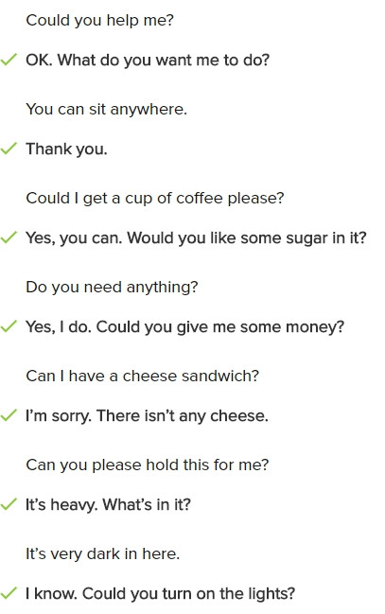

**Conversation**

Hello, welcome the Sando restaurant. Are you here for dinner?

Yes, Could I get a table for four please?

Yes, you can. where could you like to sit?

Can we sit over there? We want to look outside.

Here are your sit.

Thank you. Could we have a menu, please?

Yes. Here it is. Can I get you some drink?

Yes. Please. Can we get four glasses of water?

Ok. Please wait a minute.

Thank you. Oh, Could you tell me your name?

My name is Mychael

Thank you. Mychael. It’s nice to meet you.

**Excersise**

Could you tell me the time please?

-> Yes. It's 6:30

Can I get the Wi-fi password?

--> Yes, it's B-A-9-3-5-T

I can help you

-> Thank you. Can you takee these bags for me?

Do you play sport?

--> Yes, I do

Can we get a menu please?

--> Yes, here it is

Could you stay here?

--> why? where are you going?

What are you doing?

--> I'm fixing the computer

Can you get me a cup of coffee please?

--> Yes, I can